Exploration 11

Kevin Cummiskey

August 28, 2019

# Perform some data analysis.

table = memory %>% group_by(group) %>% summarise(mean(letters),  
 sd(letters),  
 mean(sleep),  
 sd(sleep),  
 mean(caffeine),  
 n())

## Warning: The `printer` argument is deprecated as of rlang 0.3.0.  
## This warning is displayed once per session.

kable(table)

|  |  |  |  |  |  |  |
| --- | --- | --- | --- | --- | --- | --- |
| group | mean(letters) | sd(letters) | mean(sleep) | sd(sleep) | mean(caffeine) | n() |
| ordered | 13.35 | 7.576105 | 6.35 | 0.8599266 | 0.35 | 20 |
| unordered | 9.80 | 4.443801 | 5.75 | 1.4464112 | 0.55 | 20 |

memory %>% ggplot(aes(x = group, y = letters)) + geom_boxplot()

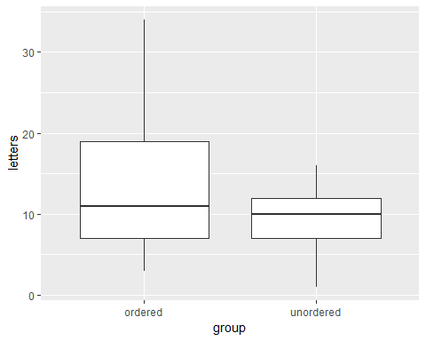

# Assess confounding by sleep

memory %>% ggplot(aes(x = group, y = sleep)) + geom_boxplot()

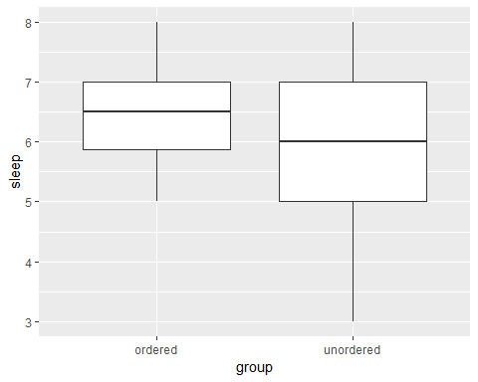

# Single Mean Model

memory = memory %>% mutate(mean1 = mean(letters))  
memory = memory %>% mutate(residuals1 = letters - mean1)  
  
#Standard error of residuals  
memory %>% summarise(sd(residuals1))

## # A tibble: 1 x 1  
## `sd(residuals1)`  
## <dbl>  
## 1 6.39

#Note this is also the same as:  
summary(lm(letters ~ 1, data = memory))

##   
## Call:  
## lm(formula = letters ~ 1, data = memory)  
##   
## Residuals:  
## Min 1Q Median 3Q Max   
## -10.575 -4.575 -1.575 4.425 22.425   
##   
## Coefficients:  
## Estimate Std. Error t value Pr(>|t|)   
## (Intercept) 11.57 1.01 11.46 4.72e-14 ***  
## ---  
## Signif. codes: 0 '***' 0.001 '**' 0.01 '*' 0.05 '.' 0.1 ' ' 1  
##   
## Residual standard error: 6.389 on 39 degrees of freedom

# Two Mean Model

memory = memory %>% group_by(group) %>% mutate(mean2 = mean(letters))  
memory = memory %>% mutate(residuals2 = letters - mean2)  
  
#Standard error of residuals  
memory %>% group_by() %>% summarise(sd(residuals2))

## # A tibble: 1 x 1  
## `sd(residuals2)`  
## <dbl>  
## 1 6.13

#Note this is also the same as:  
summary(lm(letters ~ group, data = memory))

##   
## Call:  
## lm(formula = letters ~ group, data = memory)  
##   
## Residuals:  
## Min 1Q Median 3Q Max   
## -10.350 -3.350 -0.575 5.650 20.650   
##   
## Coefficients:  
## Estimate Std. Error t value Pr(>|t|)   
## (Intercept) 13.350 1.389 9.613 1.01e-11 ***  
## groupunordered -3.550 1.964 -1.808 0.0786 .   
## ---  
## Signif. codes: 0 '***' 0.001 '**' 0.01 '*' 0.05 '.' 0.1 ' ' 1  
##   
## Residual standard error: 6.211 on 38 degrees of freedom  
## Multiple R-squared: 0.07917, Adjusted R-squared: 0.05494   
## F-statistic: 3.267 on 1 and 38 DF, p-value: 0.0786